Machine Learning Internship With
ANALYST LAB AFRICA

WEEK 4: LINEAR AND LOGISTIC REGRESSION MODELLING AND EVALUATION

Report By: IBINABO DIREH

PROBLEM STATEMENT
1. To build a supervised regression model that predicts the median house value for California districts.
2. To build a classification model that predicts whether an individual passenger survived or died.

DATASET USED
1. The California House Prices Dataset (Kaggle)
2. The Titanic Dataset (Kaggle)

ALGORITHMS USED
1. Linear Regression
2. Logistic Regression

MODEL PERFORMANCE
1. Root Mean Square Error = 69411.2
This is a poor score. It is about 33 % error compared to the mean of the actual target values.
2. Accuracy Score = 79.9%
Compared to the baseline of predicting that everyone died (62%), the accuracy of 79.9% is a good score.

CHALLENGES FACED
Regression:
1. The artificial capping of values at $500,001 placed a ceiling on highly valued houses hence causing the model to under predict house values and inflate RMSE at upper boundaries. There were 965 rows at the capped value (which is about 4 percent of the test data). For understanding, other value prices just below the cap had 122 lows or less. This clearly demonstrates an imbalance in values.
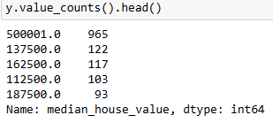

2. The ISLAND ocean proximity feature had a very small sample size (4 rows) in the train data which led to an unstable/unreliable coefficient estimate, making it the most weighted of the model's coefficients even over median house income.
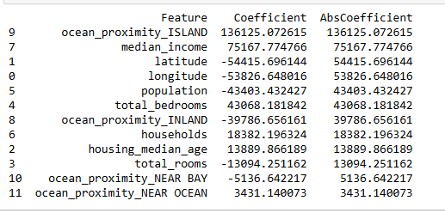
I attempted to eliminate this problem by dropping the ISLAND proximity data points. This was done in a seperate notebool to document the previous processes.
3. Multicollinearity was shown to exist between features such as household, total rooms, total bedrooms and population, as shown by the correlation coefficient (0.86 to 0.97). And also between latitude and longitude (-0.92).

Classification:
The Logistic Regression algorithm hit its maximum iteration limit before finding a stable minimum. This was mainly due to feature scale disparity. Instead of just increasing the iteration ceiling, the problem was better resolved by scaling features using Standard Scaler.

KEY FINDINGS

Regression:
- The correlation heatmap reveals that the highest correlation with the target (median_house_value) is median_income (0.69). There seems to be a weaker correlation to the rest of the numerical features.
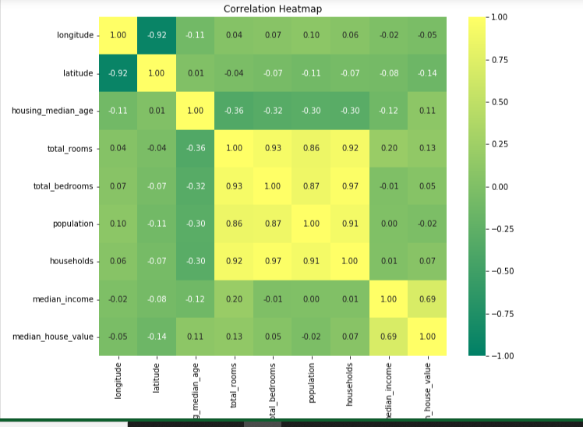

- Ocean Proximity signals clearly as a valuable predictive feature as it shows distinct patterns in relation to house values.

- Geographical coordinates (longitude and latitude) showed low correlations to the target as individual features (-0.05 and -014) but together, they clearly show a pattern, revealing a cluster of high-value houses at the coastlines, with inland houses showing significantly lower house values. This demonstrates that correlation coefficient alone may not suffice to determine the relevance of a feature in training the model.
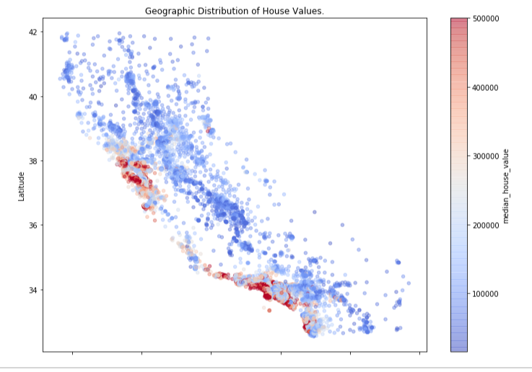

Classification:
The model’s weighted coefficients revealed lower survival rates for Males and third class passengers which fits perfectly with the real world narratives of "women and children first". And also the special treatment given to the more wealthy ones.

RECOMMENDATIONS (Future Improvements)
1. Application of a more non-linear model like Random Forest which has more complexity to match fit the data.
2. Using regularised linear regression models like Lasso, Ridge and Elastic Net.
3. Using Variance Inflation Factor (VIF) method in feature selection.
4. Dealing with collinear features by log transformation or ratio combination.
5. Combine with other evaluation scores as RMSE may not be enough to understand the model’s performance.
I could not explore and apply the above due to time constraints.

